NAME : Harshit Deepak Kadam
AF Code: AF05047333

Create a database named TrainingDB
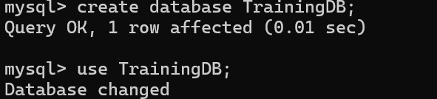

Inside the database, create two tables:
1)Students table to store student details(Rollno(primary key),name,email,contact,pinno)
2)Courses table to store courses offered(cid(primary key),cname,rollno) here rollno is foreign key.

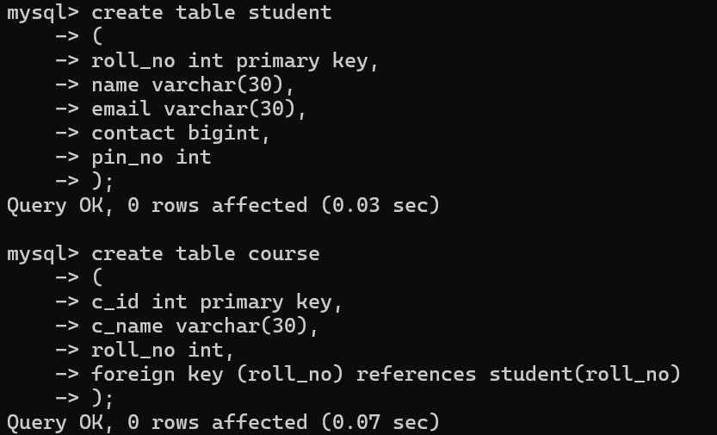

Q.2)Insert minimum 5 records in each table.

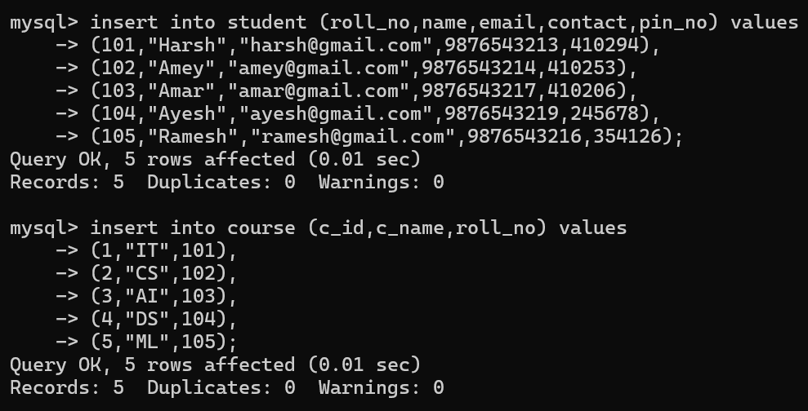

Q.3) View all the records.

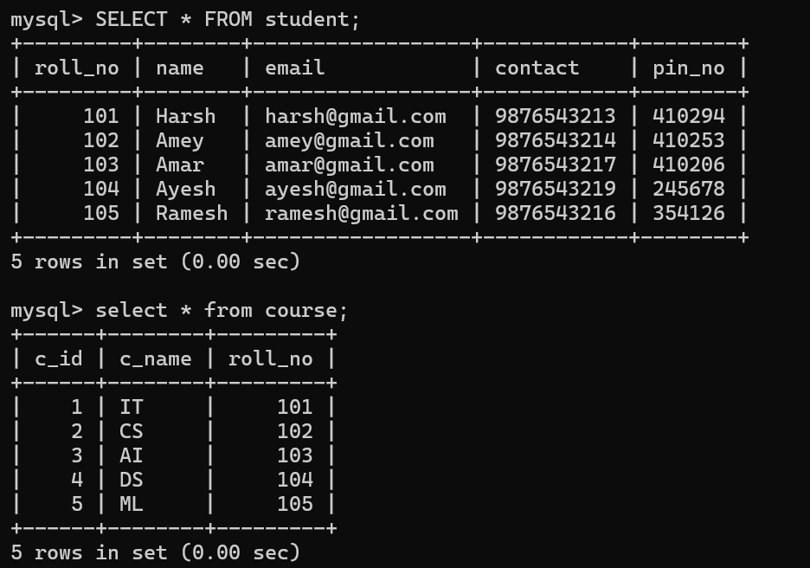

Q.4) Update contact whose rollno is 101.

